**Atlanta Suburb Town Center Evaluation with a Focus on Restaurant Type and Quantity**

**Introduction**

The Atlanta, Georgia area has had huge success in the development of suburb downtown centers. Many suburbs have developed the downtown centers with a variety of retailers. For this project, we will evaluate the types and numbers of restaurants within walking distance from the downtown centers. We will be able to establish which restaurant types are most common and which restaurants may be lacking within the individual suburb town centers.

By analyzing this data, we can provide recommendations where there may be growth opportunities for establishing new restaurants within each suburb town center. We will also be able to conclude which types of restaurants are key to making the most popular town centers a success. Our analysis will also allow us to evaluate whether the official GPS location of a town center is the true center of the successful retail experience.

Developers and investors will be able to assess what types of restaurants and locations are best for potential business opportunities.

Our evaluation will start with the following suburbs of Atlanta, GA:

Dunwoody

Sandy Springs

Roswell

Woodstock

Norcross

Suwanee

Alpharetta

Marietta

Duluth

**Data**

The Foursquare API will be used to explore the various suburb town centers around Atlanta, GA and the restaurant venue category will be used for the study. We have chosen only restaurant type for this analysis in the hope that we will have a statistically significant amount of data for each suburb in the study.

One main venue category will capture all the restaurants for each suburb:

(4d4b7105d754a06374d81259)

A sample set of data from Foursquare is below showing the types and number of restaurants in the Alpharetta suburb:

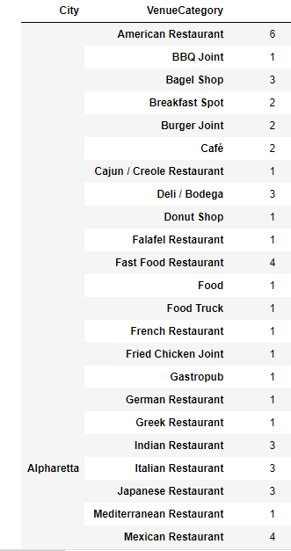

We will be identifying each town center’s GPS location and then evaluate the restaurants within 2000m of the known town center. 2000m should capture the restaurants within walking distance of the town centers. Googles Geocoding API will be used for identifying the established latitude and longitude of each town center.

The town centers for the initial selection of towns is illustrated below:

